Chapter 1

Introduction

1.1 Purpose

A software design is a meaningful engineering representation of

some software product that is to be built. During the design process the

software specifications are transformed into design models that describe the

details of the data structures, system architecture, interface, and components.

Each design product is reviewed for quality before moving to the next phase

of software development. At the end of the design process a design

specification document is produced. This document, called the Software

Design Document is composed of the design models that describe the data,

architecture, interfaces and components.

A software design document (SDD) is a written description of a

software product, that a software designer writes in order to give a software

development team an overall guidance of the architecture of the software

project. Practically, a design document is required to coordinate a large team

under a single vision.

The proposed system aims to improve the power efficiency of the

android device by building a customized Android ROM(similar to an operating

system) which would make the installation of the stock applications optional.

Power efficiency will also be improved by making changes to the kernel to

bring about controlling the processor speeds to obtain maximum power

efficiency.

In building the ROM from the source code additional features like

support for native languages like Malayalam can be brought about.

1.2 Scope

The Scope of this document is to cover all the aspects involved in the software design procedure in building a customized android ROM.It includes details about the various modules included in the customized ROM.It also shows how the user interacts with the ROM and what kind of output it produces through that interaction through data flow diagrams.The deatailed description of Android Architecture is also specified.

1.3 References

• http://developer.android.com/index.html

• http://forum.xda-developers.com/

• https://developers.google.com/

• www.droidforums.net

Chapter 2

Defnitions,Acronyms &

Abbreviations

2.1 Defnitions

JDK:-The Java Development Kit (JDK) is an Oracle Corporation product aimed at Java deve-

opers. Since the introduction of Java, it has been by far the most widely used Java SDK. On 17

November 2006. Sun contributed the source code to the OpenJDK.

Android SDK:-The Android software development kit (SDK) includes a comprehensive set of development tools. These include a debugger, libraries, a handset emulator , documentation, sample

code, and tutorials. Currently supported development platforms include computers running Linux

(any modern desktop Linux distribution), Mac OS X 10.4.9 or later, Windows XP or later. The

officially supported integrated development environment (IDE) is Eclipse using the Android Development Tools (ADT) Plugin, though developers may use any text editor to edit Java and XML

files then use command line tools (Java Development Kit and Apache Ant are required) to create,

build and debug Android applications as well as control attached Android devices (e.g., triggering

a reboot, installing software package(s) remotely).

AVD:- AVD is the Android Virtual Device , which is helpful in running the application in a computer.

AVD is a virtually creates a mobile device,which helps in running the application in a computer.The

program running in avd seems to be like running the application in android mobile phone.

Ambiguity between SDK and JDK:- The JDK forms an extended subset of a software development

kit (SDK). In the descriptions which accompany its recent releases for Java SE, EE, and

ME, Sun acknowledges that under its terminology, the JDK forms the subset of the SDK which

has the responsibility for the writing and running of Java programs. The remainder of the SDK

comprises extra software, such as application servers, debuggers, and documentation.

2.2 Abbreviations

SDK :-Software Development Kit

NDK :-Native development kit

AVD :-Android Virtual Device

GUI :-Graphical User interface

The main components in building a rom includes a device and a computer running Linux with a few necessary packages installed like Java Development Kit 6,Android Virtual Device, Android SDK .The AVD is a android device emulator which works as an android phone. The prepared rom can run on this virtual device. The ROM will be developed by compiling from the android source code provided by Google. After the primary compilation different modifications are made to the ROM to make it power efficient.

The main development environment for the Rom is Android SDK.It contains all the packages necessary for compiling the source code of the Android OS and AVD's which can be used for installing and testing the developed ROM. The example of an Android SDK is shown below. The device is HTC Wildfire for which the proposed ROM is developed.

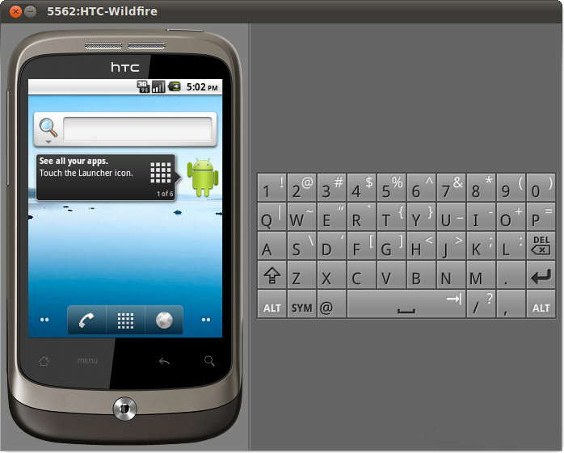

Chapter 4

Architectural Design

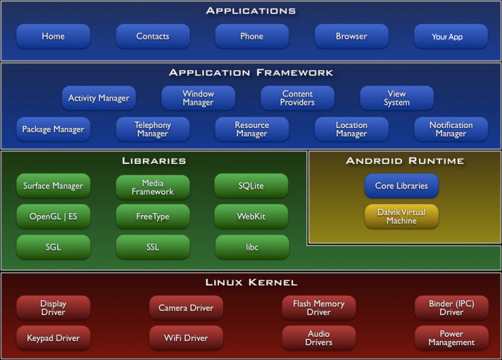

The above figure shows the diagram of Android Architecture. The Android OS can be referred to as a software stack of different layers, where each layer is a group of several  program components. Together it includes operating system, middleware and important applications. Each layer in the architecture provides different services to the layer just above it. We will examine the features of each layer in detail.

**Linux Kernel**

The basic layer is the Linux kernel. The whole Android OS is built on top of the Linux 2.6 Kernel with some further architectural changes made by Google.  It is this Linux that interacts with the hardware and contains all the essential hardware drivers. Drivers are programs that control and communicate with the hardware. For example, consider the Bluetooth function. All devices has a Bluetooth hardware in it. Therefore the kernel must include a Bluetooth driver to communicate with the Bluetooth hardware.  The Linux kernel also  acts as an abstraction layer between the hardware and other software layers. Android uses the Linux for all its core functionality such as Memory management, process management, networking, security settings etc. As the Android is built on a most popular and proven foundation, it made the porting of Android to variety of hardware, a relatively painless task.

**Libraries**

The next layer is the Android’s native libraries. It is this layer that enables the device to handle different types of data. These libraries are written in c or c++ language and are specific for a particular hardware.

**Some of the important native libraries include the following:**

**Surface Manager:**It is used for compositing window manager with off-screen buffering. Off-screen buffering means you can't directly draw into the screen, but your drawings go to the off-screen buffer. There it is combined with other drawings and form the final screen the user will see. This off screen buffer is the reason behind the transparency of windows.

**Media framework:**Media framework provides different media codecs allowing the recording and playback of different media formats

**SQLite:** SQLite is the database engine used in android for data storage purposes

**WebKit:**It is the browser engine used to display HTML content

**OpenGL:**Used to render 2D or 3D graphics content to the screen

**Android Runtime**

Android Runtime consists of Dalvik Virtual machine and Core Java libraries.

**Dalvik Virtual Machine**

It is a type of JVM used in android devices to run apps and is optimized for low processing power and low memory environments. Unlike the JVM, the Dalvik Virtual Machine doesn’t run .class files, instead it runs .dex files. .dex files are built from .class file at the time of compilation and provides higher efficiency in low resource environments. The Dalvik VM allows multiple instance of Virtual machine to be created simultaneously providing security, isolation, memory management and threading support. It is developed by Dan Bornstein of Google.

**Core Java Libraries**  
These are different from Java SE and Java ME libraries. However these libraries provides most of the functionalities defined in the Java SE libraries.

**Application Framework**

These are the blocks that our applications directly interacts with. These programs manage the basic functions of phone like resource management, voice call management etc. As a developer, you just consider these are some basic tools with which we are building our applications.

**Important blocks of Application framework are:**

**Activity Manager**: Manages the activity life cycle of applications

**Content Providers:**Manage the data sharing between applications

**Telephony Manager:** Manages all voice calls. We use telephony manager if we want to access voice calls in our application.

**Location Manager:**Location management, using GPS or cell tower

**Resource Manager:**Manage the various types of resources we use in our Application

**Applications**

Applications are the top layer in the Android architecture and this is where our applications are gonna fit. Several standard applications comes pre-installed with every device, such as:

* SMS client app
* Dialer
* Web browser
* Contact manager